

**Department of Software Engineering**

**Faculty of Computer Science & Information Technology**

**The Superior University, Lahore**

**Name:** MUHAMMAD HAMZA ALI

**Roll No:** SU92-BSAIM-S24-032

**Section:** 3A

**Subject:** ARTIFICIAL INTELLIGENCE(LAB)

**Task No:** Mini Project(Lab Task-1)

**Mini Project**

**To-Do List**

**1. Introduction:**

The Todo list mini project is a command-line application designed to help users manage their daily tasks efficiently. The application allows users to add, remove, mark tasks as completed, and view the list of tasks. The project is implemented in Python and follows a simple yet functional approach to task management.

**2. Features:**

The application provides the following features:

* **Add Task:** Users can add new tasks to their Todo list.
* **Remove Task:** Users can remove tasks using their index in the list.
* **Complete Task:** Users can mark tasks as completed.
* **View Tasks:** Users can view all pending and completed tasks.
* **Exit:** Users can exit the application.

**3. Implementation Details:**

The project is implemented using an object-oriented approach with a Todo list class that manages tasks. The class includes methods to handle different functionalities:

* add_task(task): Adds a new task to the list.
* remove_task(task_index): Removes a task based on its index.
* complete_task(task_index): Marks a task as completed.
* view_task(): Displays all tasks with their status.

**4. User Interaction:**

* The application runs in a loop, presenting a menu to the user with options to manage tasks.
* User input is taken to perform actions based on the menu selection.
* Input validation is included to ensure that the user provides valid indices for task operations.

**5. Code Structure:**

The main components of the code are:

* TodoList Class: Handles task management operations.
* Main Function(main()): Provides the user interface and menu-driven interaction.
* Loop Mechanism: Ensures the application runs continuously until the user decides to exit.

**6. Example Usage:**

* Users can add tasks like “Buy groceries”, “Finish homework”, etc.
* They can view the list of tasks, remove any task by its index, or mark tasks as completed.

**7. Output:**

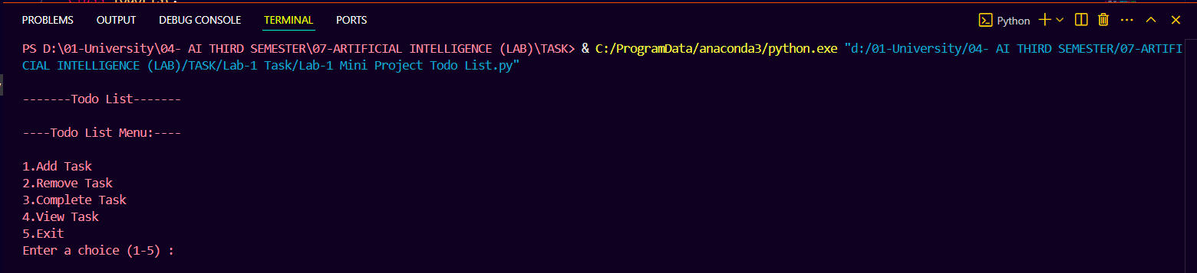

**8. Conclusion:**

* The Todo List application is a straight forward yet effective tool for task management.
* It demonstrates basic programming concepts such as classes, methods, and user input handling in Python.